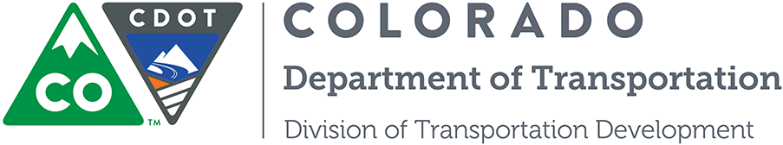

Personal Protective Equipment Understanding Form

I ____________________________________________ understand that I am entering an active construction site. I understand that Personal Protective Equipment (PPE) is required at all times within the site. Required PPE shall consist of: hard hat, safety vest, work pants (no shorts or skirts) and sturdy work boots. The Colorado Department of Transportation (CDOT) takes safety seriously, therefore in addition to the above PPE, additional safety guidelines will be given by your instructor.

CDOT BMP Training Facility is a No Smoking zone. Smoking is not allowed anywhere inside the facility, but designated smoking areas outside of the facility will be available. Any student who does not obey the PPE requirements and smoking policy will be asked to leave and must retake this portion of the certification at a later date.

At CDOT, your safety is our number one priority. If you see anything unsafe alert your instructor immediately.

By signing below, I understand the given policy and understand that a hard hat, safety vest, work pants (no shorts or skirts) and sturdy work boots will be worn within the work area of the facility at all times and that there is no smoking within the facility.

Signature of Participant: ____________________________________ Date: ______________

